FOR IMMEDIATE RELEASE

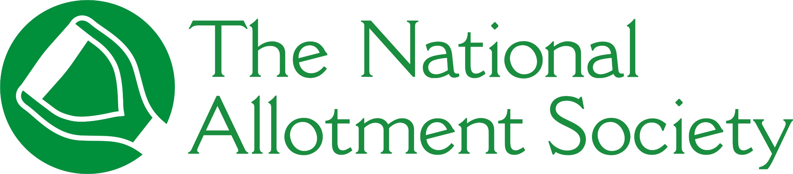

PRESS RELEASE

[April]

National Allotment Society launches first nationwide audit of UK plots in 30 years

The National Allotment Society (NAS), the UK’s leading representative body for allotment holders, has launched a nationwide survey to map the current state of allotment provision, demand and management across England.
The survey – the first of its kind in 30 years – has been distributed to over 9,000 councils. The findings will provide vital, evidence-based data to enable local authorities, planners and policymakers to shape planning and provision to meet future demand for growing space.

Since the last NAS audit in 1996, the UK has seen significant changes in population, urban development and land availability. Since the COVID-19 pandemic, there has also been increasing public interest in ‘growing your own’ food produce and being out in nature for wellbeing and mental health benefits.

Thirty years ago, the previous survey of its kind recorded 7,796 sites and 296,923 plots – an average of 15 plots per 1,000 households. Data from this latest survey is anticipated to show a vastly different landscape.
Commenting on the launch of the survey, Sonia Gallagher, NAS Secretary and Office Manager, said: “As a membership organisation representing over 132,000 members, we know first-hand the positive impact that allotments have on the community. That’s why this survey is vital to protect these spaces for the future.

“The valuable data provided in the survey will allow us to accurately gauge waiting lists for allotments, so that they remain good, sound and safe spaces that will look after generations to come.”

Local authorities or councils responsible for allotments can complete the survey here: https://www.smartsurvey.co.uk/t/TheNAS/

For more information about the National Allotment Society, visit https://thenas.org.uk.

[ENDS]

Please direct any press enquiries to Emma Speirs on 01536 682800 or email emma.speirs@ballyhoo-pr.co.uk

NOTES TO EDITORS

[Photography]
The National Allotment Society has launched a nationwide survey to map the current state of allotment provision, demand, and management across England.

About the National Allotment Society
With over 132,000 members, The National Allotment Society (NAS) is the leading representative body for UK allotment holders. Its mission is to protect, promote and preserve allotments for future generations.

NAS works with allotment sites, associations, councils and individual plot holders to provide advice and guidance on a range of issues including site management, environmental concerns, tenancy agreements and fundraising.

For more information, go to https://thenas.org.uk/ or follow NAS on Facebook and Instagram

